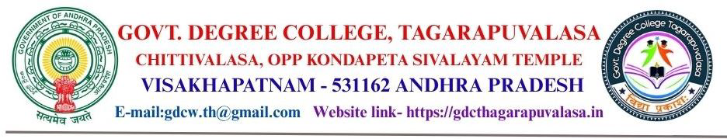
Faculty Profile

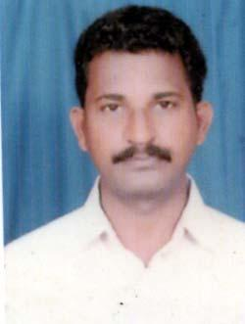

Name : Dr. CH. VIJAYA KUMAR
Designation : Lecturer in Mathematics

E-Mail: vijay.chalumuri123@gmail.com
Mob: 9441713539

Date of Birth : 31-08-1976

Highest Qualification : M.Sc., B.Ed., APSET,Ph.D.

Date of Joining in Present Cadre : 23-05-2013

Prior to Govt. Service : 1. SGT FROM Feb 15th 2002 to July 3rd 2008.
2. Junior Lecturer from 04-07-2008 to 22-05-2013.
3.Lecturer from 23-05-2013 to till to date
Address (Res) : Rupa Residency ,Flot No 203 Vivekananda Nagar ,
Yendada ,Visakhapatnam
Academic Qualifications : M.Sc., Andhra University

Specialization : Number theory,L.P.G.T

Teaching Experience : 24 Years

National / International workshops / Seminars / Conferences attended:

Conferences/Seminars/Workshops organized/Attended:

- One workshop on Indian Banking –Trends and Challenges on 20-09-2014.
- National workshop on recent trends in Algebra and its Applications held in K.B.N College, Vijayawada on 19th -20th Feb -2015.
- One day National seminar on Advanced in Mathematical Sciences held in K.B.N. College , Vijayawada on 28-11-2015.
- Refresh course on interdisciplinary at Andhra University from 11-07-2016 to 31-07-2016.
- One day International Webinar on VECTOR SPACES OVER PRE-ALGEBRAS organized by Department of Mathematics, Government Degree College, Narsipatnam on 17th September 2020.
- Two day National Webinar on REAL ANALYSIS organized by Department of Mathematics, Maris Stella College, Vijayawada on 19th, 20the January 2021.
- 5 day workshop on LATEX organized by Department of Mathematics, School of Science, GITAM, Bangalore held from 5th to 9th July 2021.
- One day national level FDP on ’’Importance of Intellectual property rights in higher education institutions” organized by dept of commerce and IQAC,SRR&CVR GOVT DEGREE COLLEGE ,VIJAYAWADA
- 5 days residential programme of TOT on ANALYTICAL SKILLS conducted by commissionerate of collegiate education in APHRDI Visakhapatnam from 12-10-2022 to 16-10-2022
- One day national workshop on PPTS and VIDEO MAKING,VIDEO EDITING THROUGH OBS& OPENSHOT SOFTWARE TOOLS on 22-10-2022 organized by dept of mathematics and IQAC,VKV GOVT DEGREE COLLEGE ,KOTHAPETA
- One day national seminar on 30-11-2022 organized by dept of mathematics &commerce,GDC ,NARASANNAPETA
- 3 day non residential programme of TOT on LMS and INTERNSHIP programme conducted by CCE at NRC Dr.V.S.K.DEGREE COLLEGE(A),VISAKHAPATNAM from 30-01-2023 to 01-02-2023
- 8 weeks online course “INTRODUCTION TO RESEARCH” through NPTEL(Feb-Apl-2022)
- Two day national seminar on NEP-2020 at Govt.college for women(A),SRIKAKULAM from 02-03-2023 to 03-03-2023
- 5 Days residential programme (TOT) on Mathematics 16-04-2024 to 22-04-2024 at N.R.C Dr.V.S.K.Degree College(A),VSKP
- 12 Weeks online course “ADVANCED LINEAR ALGEBRA” through NPTEL(JAN-APR 2025)
- O ne week national level FDP on "APPLICATIONS OF MATHEMATICS IN MULTI DISCIPLINARY DOMAINS” from 01-02-2024 to 08-02-2024 By A.C.T Academy,Kerala and The American College,Madurai,Tamilnadu
- 3 Days National level workshop on “VEDIC MATHEMATICS AND ADVANCED APPLICATIONS” from 23, 24 &27 th Feb -2024 by A.C.T. AACADEMY,KERALA
- A paper presented in two day International conference on “Pure Applied and Engineering Mathematical Sciences” by Andhra University,UASMS &SMSMS on 30-03-2024 to 31-03-2024.
- A paper presented in two day International conference on “Recent Trends & Innovations in Mathematics,Statistics and Mathematical Computing ” by IGU,Meerapur,Haryana on 05-03-2025 to 06-03-2025.
- 2 Day International seminar on “COMPUTATIONAL TECHNIQUES IN MATHEMATICS” by The dept of Mathematics,Adikavi Nannaya University,RJY on 25-26 sep 2025
- 5 Day national webinar and FDP on“TRANSFORMATIVE EDUCATION FOR THE FUTURE: INNOVATIONS IN PEDAGOGY, RESEARCH AND KNOWLEDGE CREATION” by JMJ College(W),Tenali from 28-07-2025 to 01-08-2025

Qualifications :
- Master’s degrees: M.Sc.(Pure Mathematics) from Andhra University, Visakhapatnam, Andhra Pradesh
- Specialization in Number Theory, Linear Programming and Game Theory
- Possess Bachelor’s Degree in Teaching from IGNOU in the Methodologies of Mathematics and Physical Sciences
- Awarded Ph.D. degree from GITAM, Visakhapatnam on 08-01-2026.

Appointments and Experience:
- Rendered valuable services at various levels of teaching Mathematics as Teacher, Junior Lecturer and Lecturer and possess an outstanding track record in instructing the students for various professional examinations like IIT, VIT, BITSAT, EAMCET etc with a vast experience of 18 years
External Examiner:
- Vast experience in Question Paper – Setting, Valuation and Re-valuation and acted as Chief Examiner for several years in BIEAP, Hyderabad, Andhra Pradesh
- Associated with the conduct of Examinations in the capacity of Departmental Officer and Chief Superintendent
- Vast experience in Question Paper – Setting, Valuation and Re-valuation to different Govt Degree Colleges(A)and acted as The member of BOS and subject expert to a several govt degree colleges (A) in AP
Hobbies and Interests:
- Logic puzzles, Vedic Mathematics and Brain Teasers
- Enthusiastic in preparing mathematical models for the usage in teaching such as PowerPoint presentations, usage of ICT, etc.
- Participation in work-shops and Seminars
- Interest in the latest technological innovations

RESEARCH PAPERS AND PUBLICATIONS:
